Here’s a breakdown of all of the editable fields and info in an EFT file that would be sent to a normal, corporate bank.  If it’s not mentioned in this guide, it’s hard coded.

First tab of “Edit Account Details” for an EFT bank:

1. Routing Code
2. Bank Name

\*Note – These can be overridden in the EFT General screen (shown on next page) with the “Format file for this Federal Reserve Bank” and “Federal Reserve Bank routing code” boxes. “Format file for this Federal Reserve Bank” will override the Bank Name and “Federal Reserve Bank routing code” will override the Routing Code. This can be used for banks which require a specific routing number for ACH payments as opposed to the normal check routing number.\*

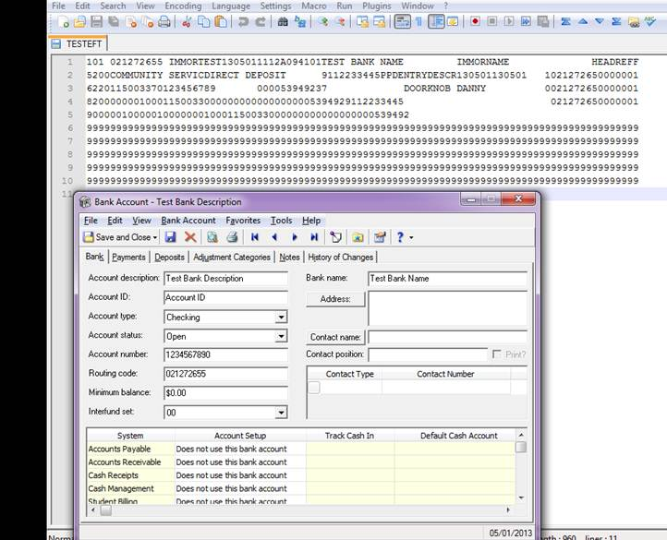



EFT General:

1. Company ID Prefix
2. Company ID Number
3. Immediate Origin
4. Immediate Origin Name
5. Header Record Reference
6. Debit Transaction – This includes a debit line for the total amount of the other side of the transaction.  Most banks do not want this option marked.  It is not active in this screenshot, for that reason. (noted in a black circle)
7. Carriage Return – This is what makes the file automatically “indent” at the correct place.  Clients often forget to mark this and then their file is a few very giant, long lines of code in notepad or something like that.  This makes it a nice block format. (noted in purple)
8. Entry Description

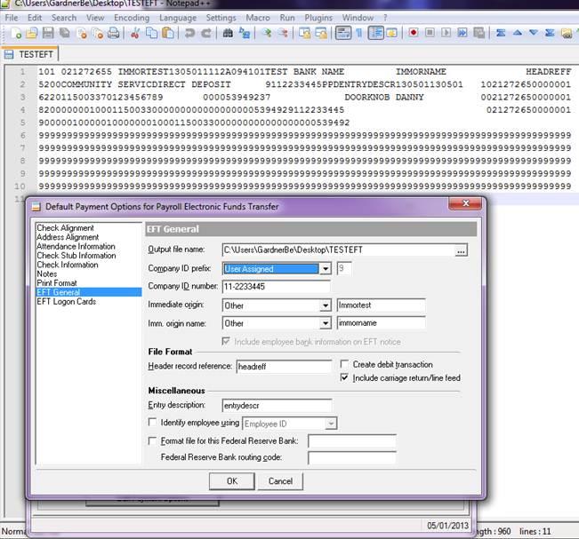

Employee’s Record/Bank Info Tab:

1. Employee Name (black circle) – This pulls from the Employee Name field from the Employee tab. (main tab)
2. Employee Routing Number
3. Employee Account Number

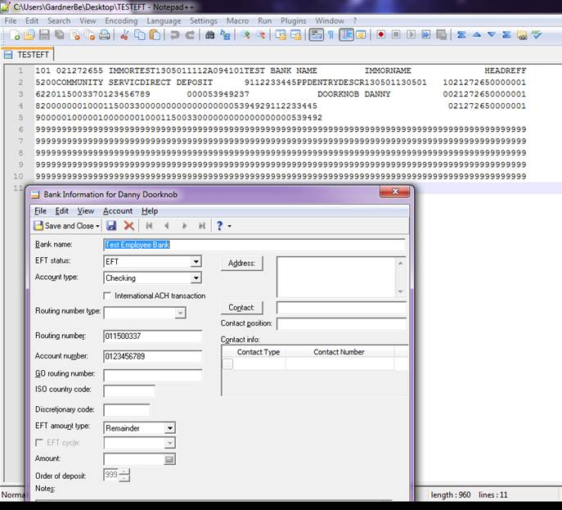

There’s one more field that can only be changed through a change database name utility.

Configuration, General (Payroll)

1. Organization Name (Database Name)

0