Blackbaud Online Express Bill Pay
Introducing a…
Fast, Easy, and Secure Method to Pay Student Bills in NetClassroom!

In NetClassroom, we now offer the ability for you to pay student bills online, let’s view how!
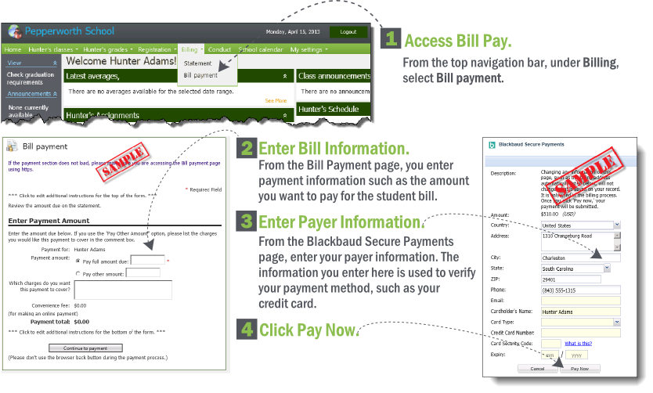

*These are sample images meant to help show you what to expect when you pay a student bill online!

How to Pay the Student Bill:
- Pay by Credit Card and/or Online Check.
- Pay Full Amount Due and/or a Partial Amount.
If you pay a partial amount, a text box may appear for you to describe what you want the payment to apply towards on the student bill.

Important Tip
Verify the email address you enter for your billing information. The email address you enter is where the payment confirmation is sent. If you do not receive a payment confirmation, contact the school billing specialist.

Important Notes about the Bill Payment Process
- The date and time of your last student bill payment appears at the top of the page.
- If you cancel during the bill payment process, you’ll receive notice that the payment was canceled.
- Your payment information is secure! Online Express Bill Pay uses Blackbaud Payment Service to process your payment in a secure transaction. Blackbaud has validated compliance with the Payment Card Industry Data Security Standard (PCI DSS) and the Payment Application Data Security Standard (PA DSS).

