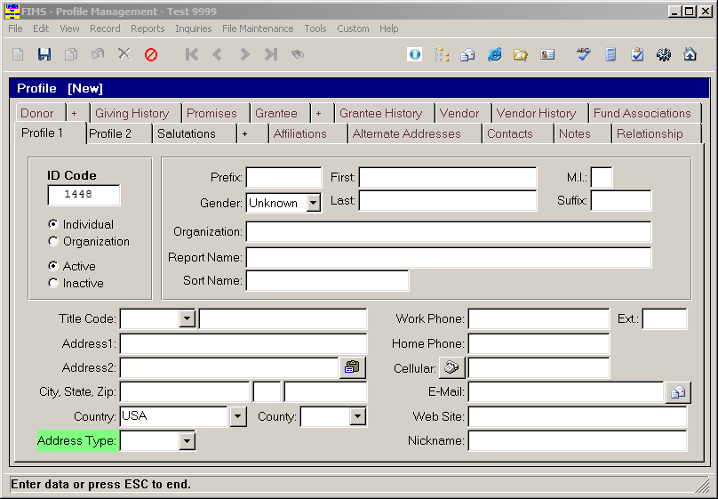
FIMS Profile Import Field Mapping

Fields relating to Profile 1:
Letters correspond to columns used on the import file
A - Organization Code | T - Address 1 | AD - Home Phone
B - Full Name | U - Address 2 | AE - Work Phone
C - Prefix | V - City | AF - Work Phone Extension
D - First Name | W - State | AG - Cellular
E - Last Name | X - Zip | AH - Fax
F - Middle Initial | Y - Country | AI - E-Mail
G - Suffix | Z - County | AJ - Web Site
H - Business Title | AB - Report Name | AQ - Profile ID Code
I - Nickname |  | AS - Address Type
S - Organization Name |  | AT - Title Code

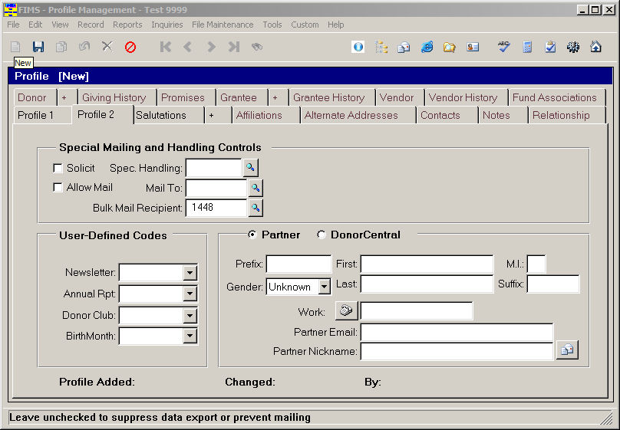

Fields relating to Profile 2:
Letters correspond to columns used on the import file
J - Partner Full Name | AK - Allow Mail
K - Partner Prefix | AL - Solicit
L - Partner First Name
M - Partner Middle Initial
N - Partner Last Name | AM - User Code 1
O - Partner Suffix | AN - User Code 2
Q - Partner Email | AO - User Code 3
R - Partner Nickname | AP - User Code 4

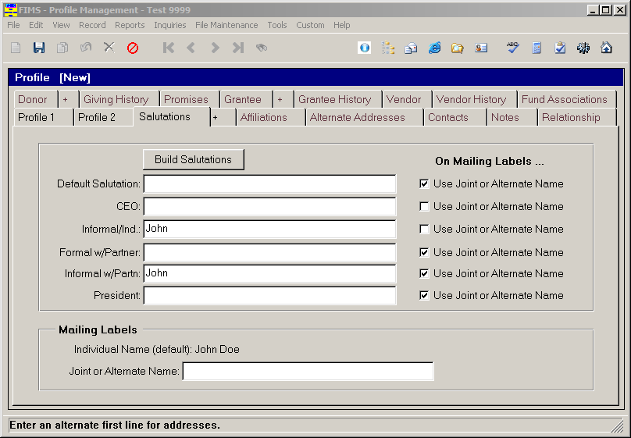

Fields relating to Salutations:
Letters correspond to columns used on the import file
AA - Joint or Alternate Name | AC - Default Salutation

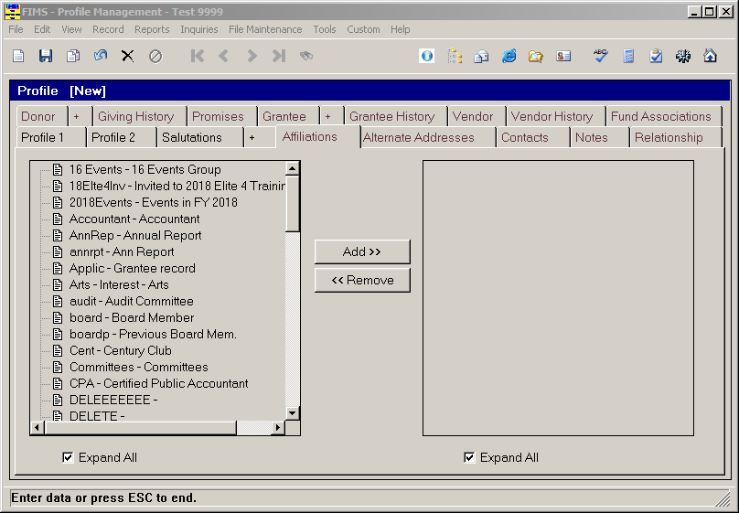

One Field relates to Affiliations:
Letters correspond to columns used on the import file
AR - Affiliations

