Target Analytics®

Fundraising Essentials for Raiser’s Edge

***Summary***

Fundraising Essentials applies advanced analytics to simplifyan organization’s fundraising approach, and drive increased performance. The process analyzes constituent profiles and giving history to accomplish three objectives – it segmentsyour

Constituents into targeted programs, recommends a *next ask amount,* and identifies each individual’s total assets. This

combination empowers an organization to realize quick-wins, and efficiently invest resourceswhere they’ll produce the most gain.

***Description***

To begin the discovery process, Target Analytics conducts an extensive review of the organization’s giving history against a

wealth of external data to find and match each donor’s likelihood to give an annual or major gift. Once segmentation is complete, each donor’s giving capacity is calculated through an analysis of their financial, demographic, behavioral**,** and lifestyle attributes;

this data is used to identify a next-ask amount that aligns with their ability and potential to give. Analytics provides an additional layer of insight by reporting each donor’s total identified assets – this is a valuable component in the development stage of fundraising, as it helps to pinpoint where and who an organization should engage with first.

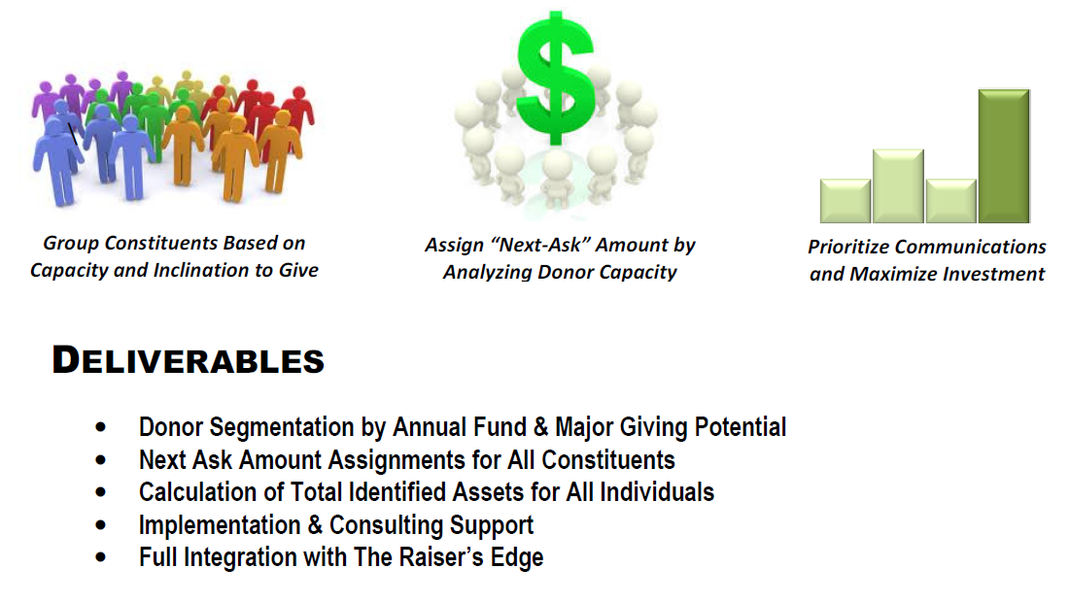



***Getting Started***

Target Analytics has made the process of exporting and uploading data necessary for Fundraising Essentials processing simple and secure.

***Installation***

The Raiser’s Edge Export Wizard can be downloaded from the Blackbaud website directly to the workstation of your choice. To download this application, go to:

<http://www.blackbaud.com/kb/index?page=content&id=BB731114>

***Complete the Wizard Prompts***

To complete the Fundraising Essentials export and file submission process, please follow the steps below:

1. On the Welcome Screen, select the Fundraising Essentials Service. Select Next.

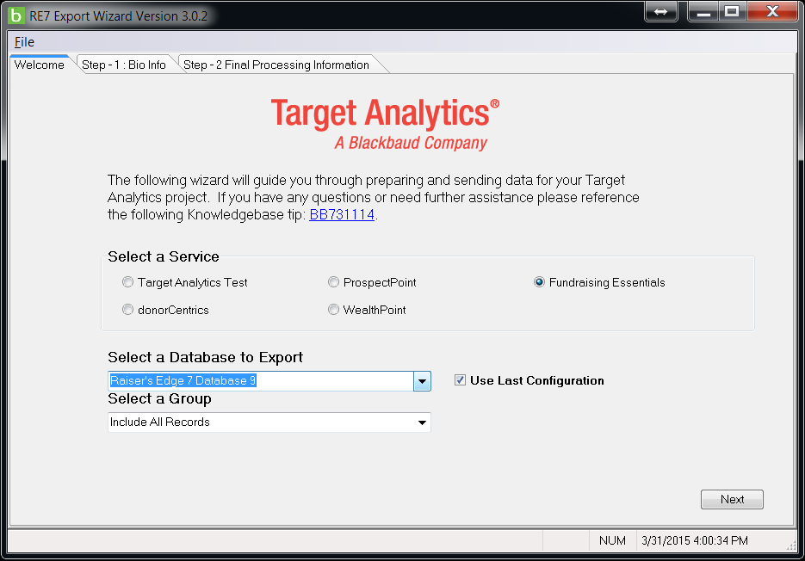



1. Step – 1: Bio Info tab contains the selection criteria for constituent home address, home phone number, and email address.

The Raiser’s Edge 7 Export Wizard will automatically select any address, phone, or email that contains the word “Home”.

If additional are needed, select them from the List of Available Addresses. Select Next.

*Please Note: Address, Phone, and Email selection and heirarchy can be completed by double-clicking or dragging and dropping.*

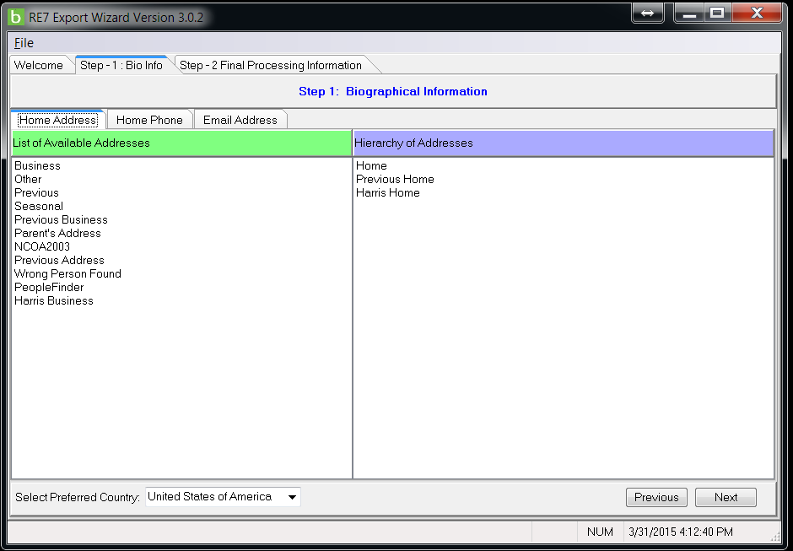



1. Step – 2: Final Processing Information tab allows you to export the Fundraising Essentials data both to your local

workstation as well as upload the data to Target Analytics. In the *Folder to place output file in:* section, browse to the local storage location of your choice for the export. Next, enter your Blackbaud SFTP credentials. Select Process.

For information regarding accessing your SFTP login information, please reference the following KnoweldgeBase tip:

[*https://www.blackbaud.com/kb/index?page=content&id=BB45967*](https://www.blackbaud.com/kb/index?page=content&id=BB45967)

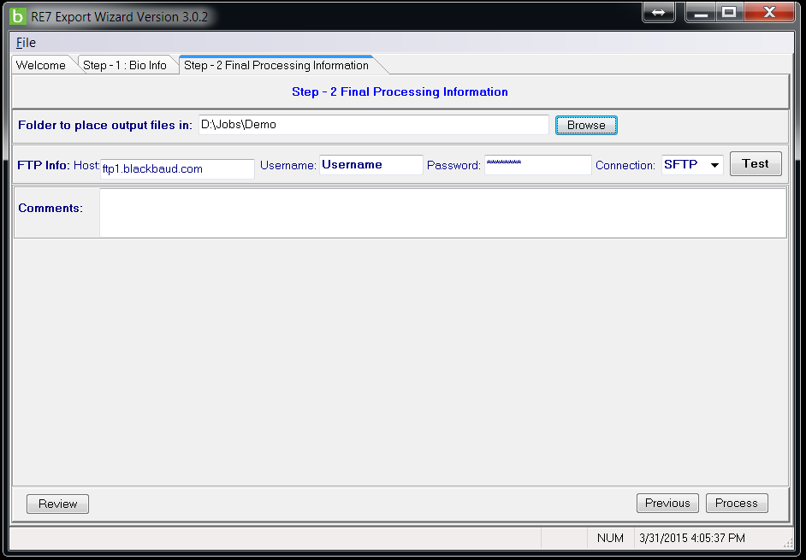

***Questions?***

The Target Analytics Support can be reached the following ways:

1. [Online Community](https://targetcommunity.blackbaud.com/)
2. [Chat Support](https://www.blackbaud.com/chat-support)
3. [Case Central](https://www.blackbaud.com/casecentral/casesearch.aspx)
4. Phone: (800) 468-8996, Option 5 (8:30am to 8pm Monday - Thursday, 9am to 8pm Friday)



***What’s Next***

*Our Three-Step Approach Reveals Your Donor’s True Giving Potential*

***Segment Your Donors***

After receiving a complete input file of your donor base, which includes giving history and general background information about your program, Target Analytics will analyze and segment your constituents into categories based on their inclination to give.

The results are used to determine whether each constituent is more likely to be an annual donor or a potential major gift prospect. Donor segmentation provides insight and understanding of how and who to best target for your fundraising initiative.

***Calculate Your Next Ask***

After segmentation is completed, Target Analytics will conduct an analysis of each donor’s financial, demographic, behavioral,

and lifestyle characteristics to gauge the appropriate next-ask amount strategy; each review provides an all-encompassing

picture of who your donors are and what interests they possess. The next-ask amount is vital to uncovering the donor’s

gift-giving potential, and allows your organization to prioritize engagement with donors based on the established fundraising strategy.

***Qualify With Hard Assets***

Target Analytics provides a final level of qualification by identifying each individual’s total identified assets; we provide the sum

total of all of their identified wealth, captured through an analysis of real estate, stock securities, company ownership, etc... This hard asset summary further qualifies each donor’s giving capacity, and will help guide your strategy by supplying the data

needed to more precisely target key constituents.